* **Objective**: Descriptive Measures.
* **Programming Language**: Python 3 or above.
* **Time Required**: 5 Hours
* **Prerequisites and Programming skill:**

1. Python 3 or above should be installed on the computer.
2. Student must have basic understanding of statistics.

* **Data:** Village level acreage data and crop condition in 4 categories (excellent, good, medium poor), is given for wheat and rice for different talukas in a district.

1.1 Express each village acreage as percent geographic area (normalize with geographic area).

1.2 Compute range, mean, median, mode, variance, std dev and coefficient of variation of village acreages in a taluka.

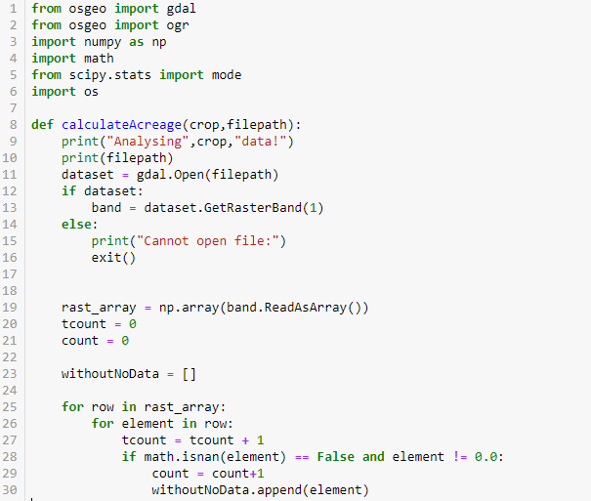

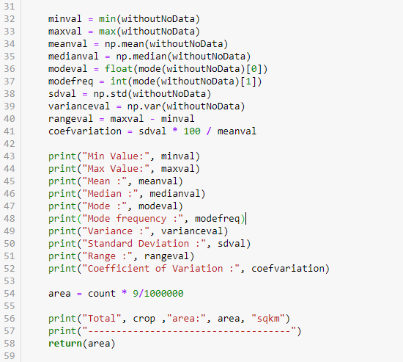

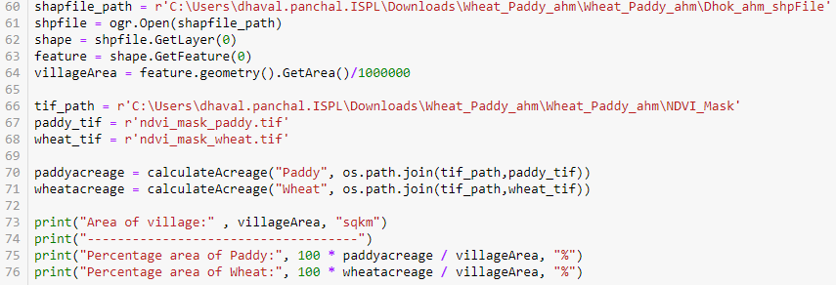

1.3 Check for any anomalous values in data – outliers. Assume normal distribution, compute and check outliers , if any.

1.4 Create histogram and cumulative histograms of data.

1.6 Create histograms and cumulative histograms for categorical crop condition data.

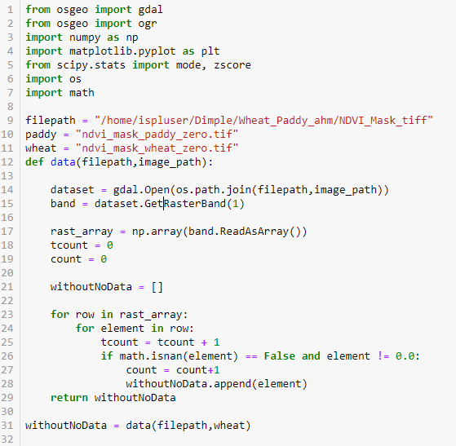

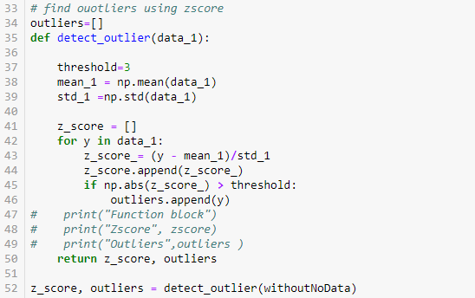

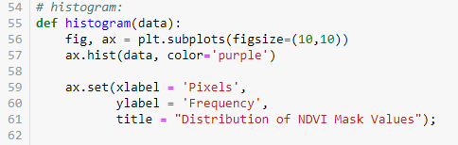

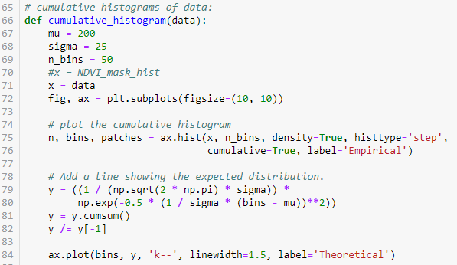

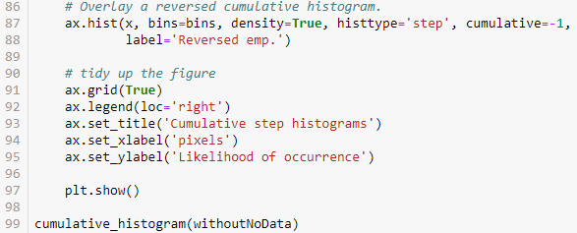

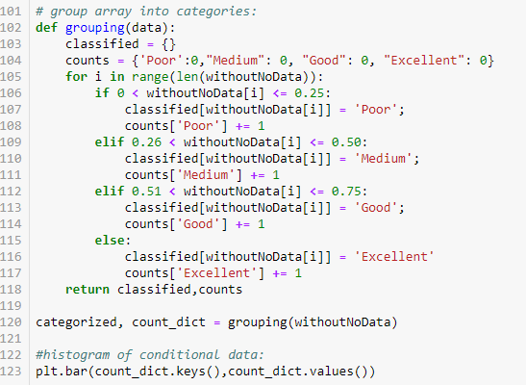

**Output:**

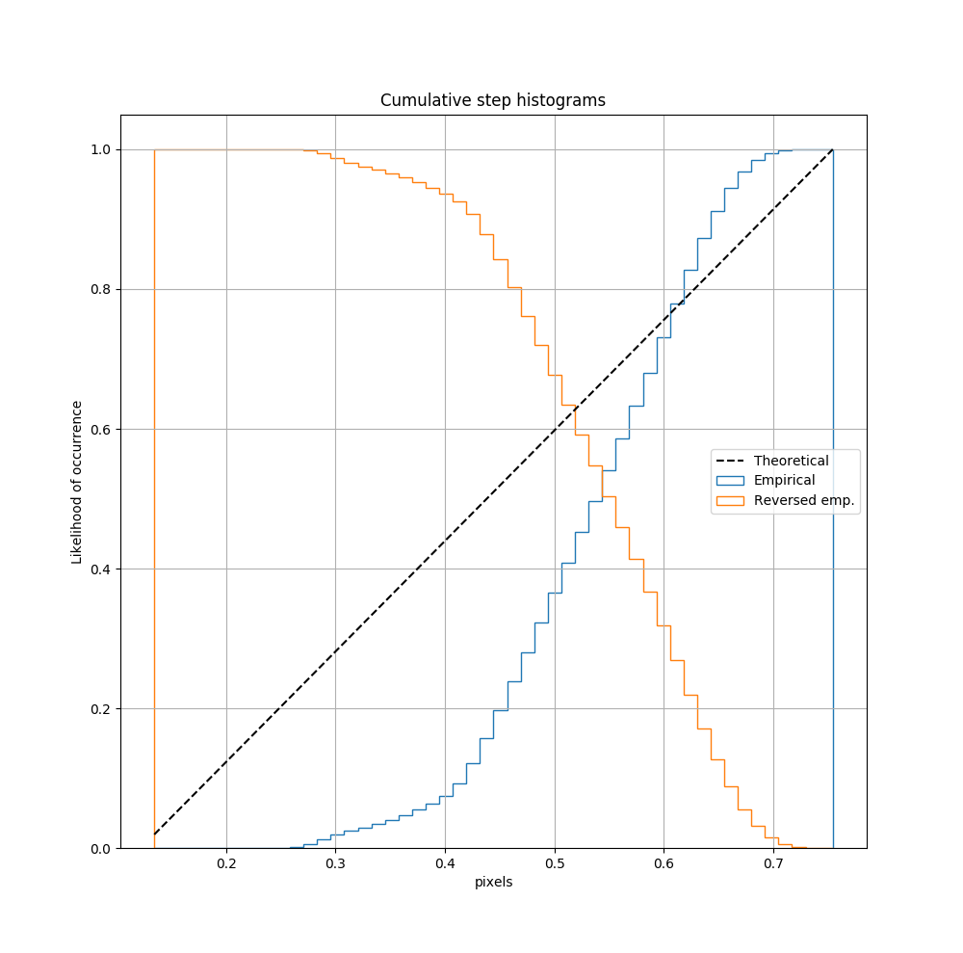

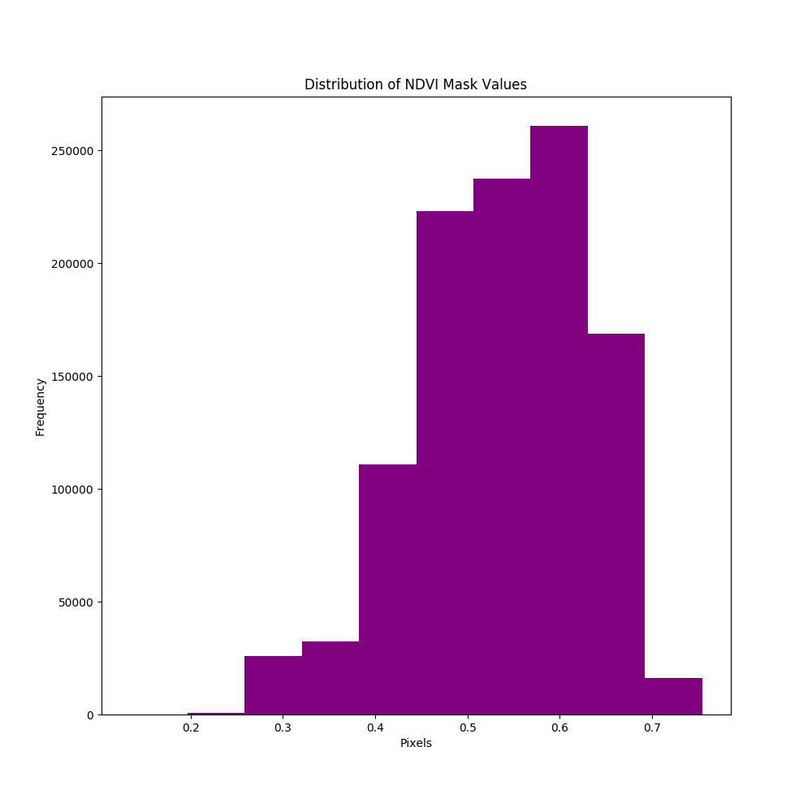

1.5 Find taluka having max and min variability.

1.7 Compare crop conditions across talukas.

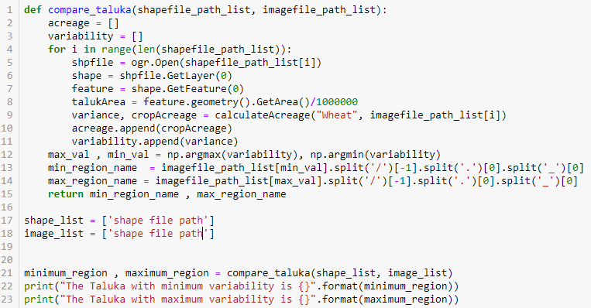

* **Objective**: Data Visualization.
* **Programming Language**: Python 3 or above.
* **Time Required**: 2 Hours
* **Prerequisites and Programming skill:**

1. Python 3 or above should be installed on the computer.
2. Student must have basic understanding of data visualization.

**Data:** village level acreage and condition data in taluka for 2 years.

* 2.1 village level acreage and condition data in taluka for 2 years.
* 2.2 Prepare bar and column charts for both years and observe changes in acreage and condition pattern.

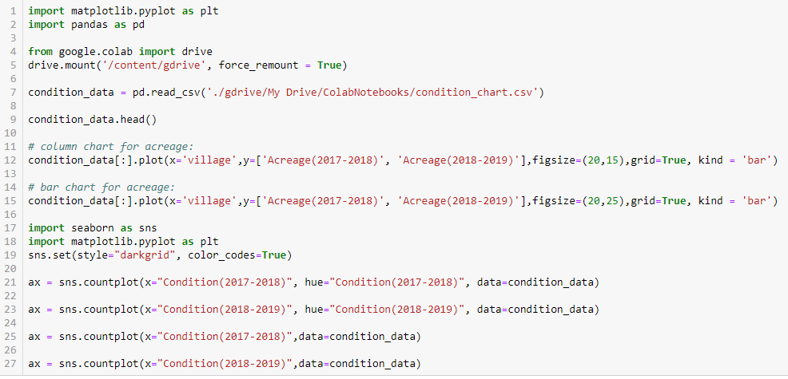

**Output:(bar_chart)**

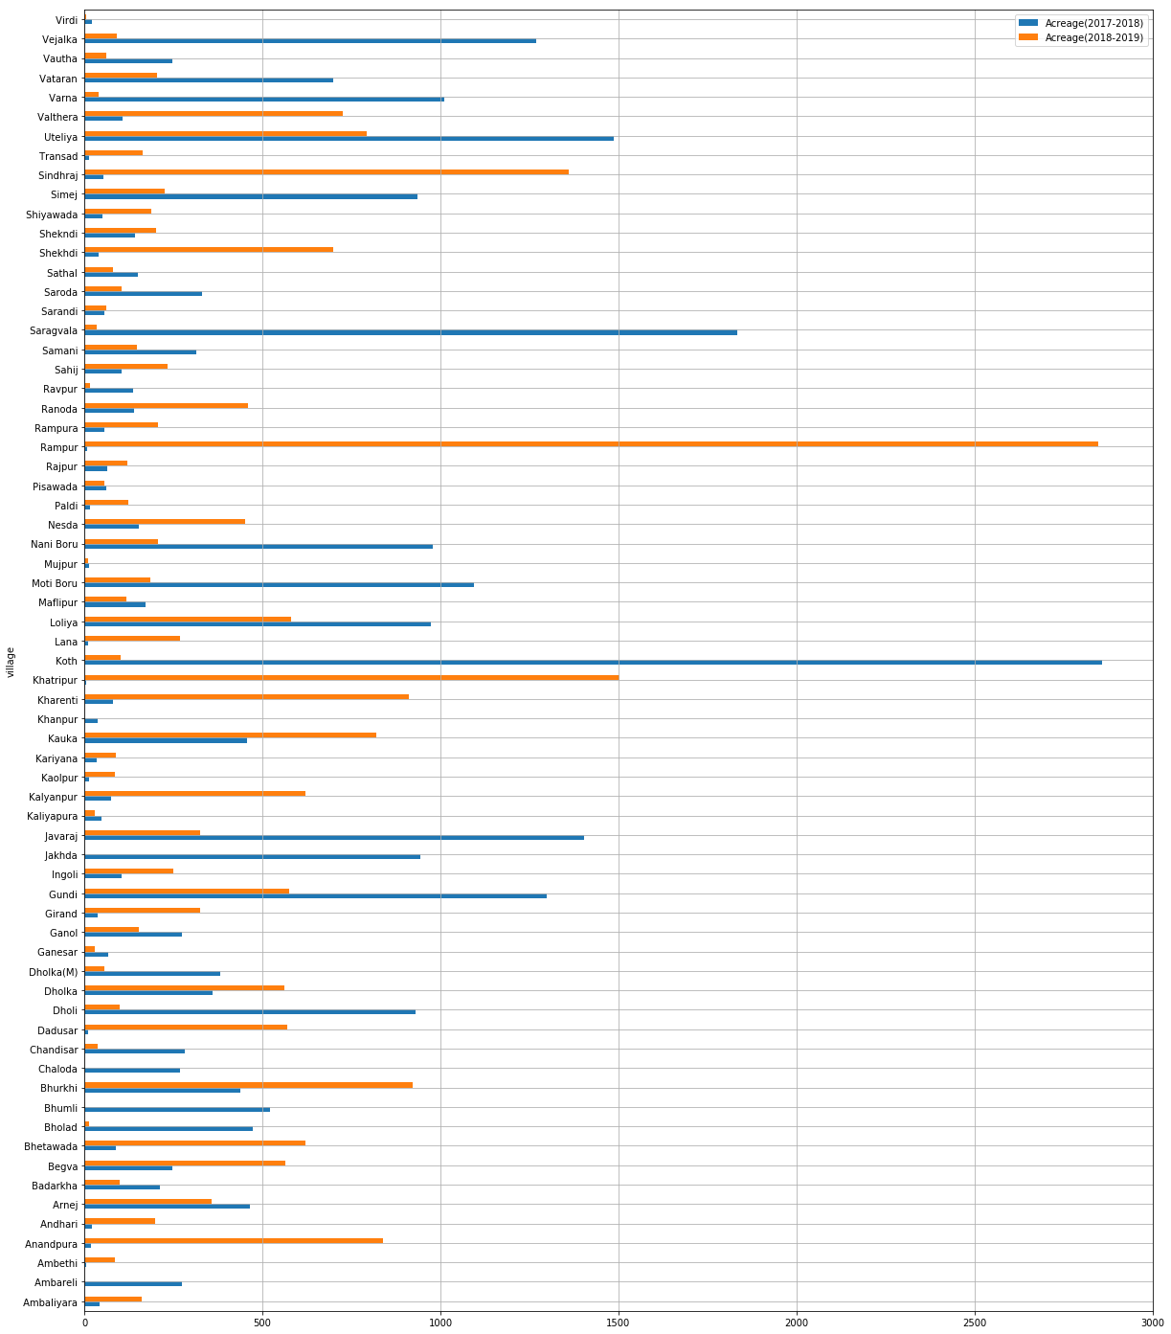

**Column_chart**:

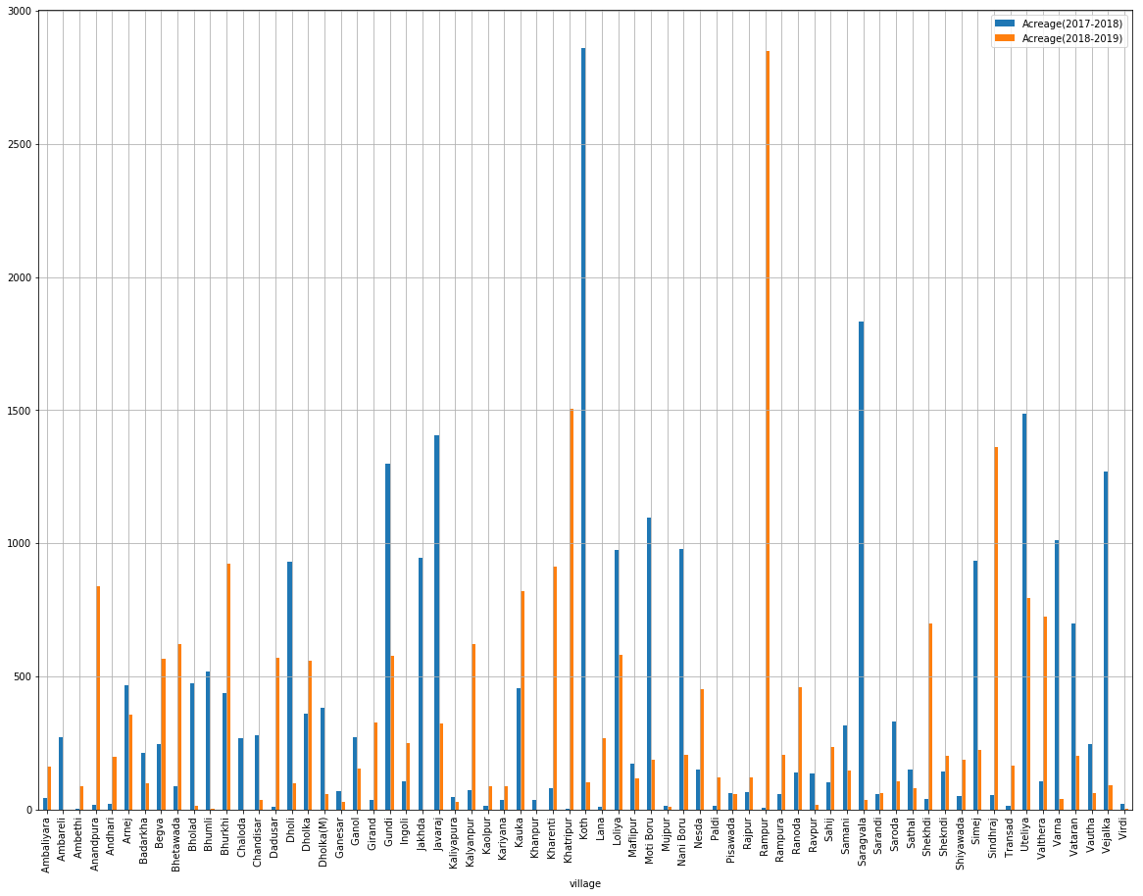

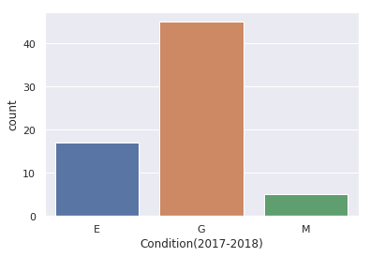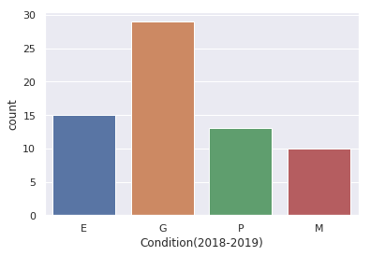

* **Objective**: Linear Regression.
* **Programming Language**: Python 3 or above.
* **Time Required**: 3 Hours
* **Prerequisites and Programming skill:**

1. Python 3 or above should be installed on the computer.
2. Student must have basic understanding of regression.

**Data:** wheat and rice yield data for a district in Gujarat for 20 or more years corresponding Rainfall and temperature data.

* 3.1 Study scatter-plots of rainfall vs yield for rice and temp vs yield for wheat.

3.2 Perform MLR on the datasets and interpret regression coefficients, their significance, t-test, F-test.

* 3.3 Use 75 % of data to develop regression model and predict yields for the rest 25% of the data,Study the errors and model performance in terms of mean absolute percentage error.

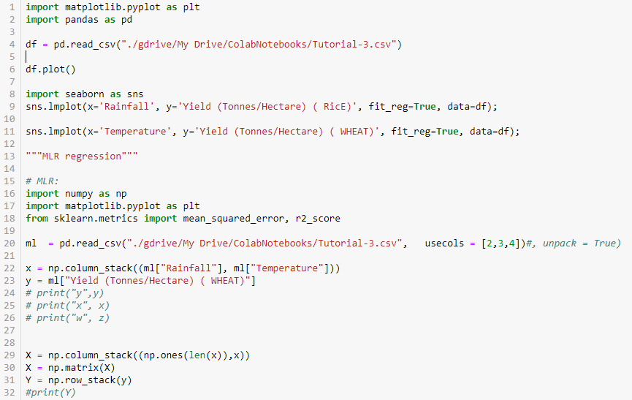

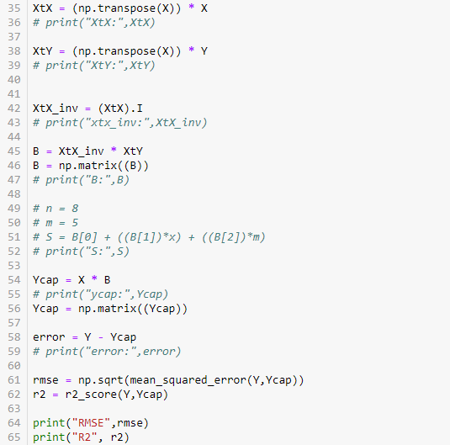

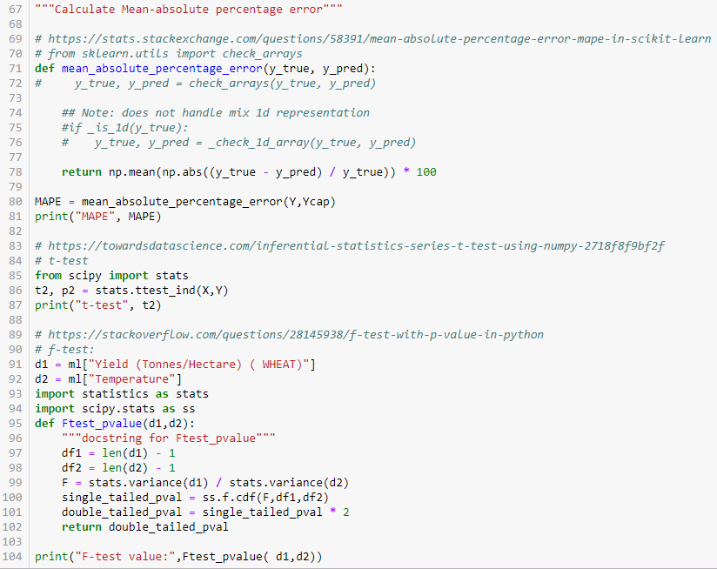

**Output:**

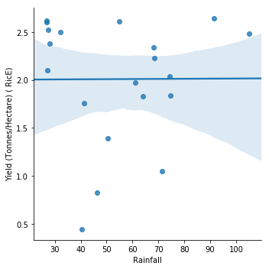

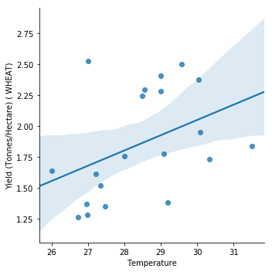

* **Objective**: Time Series Analysis.
* **Programming Language**: Python 3 or above.
* **Time Required**: 3 Hours
* **Prerequisites and Programming skill:**

1. Python 3 or above should be installed on the computer.
2. Student must have basic understanding of regression.

**Data:** FAO India level wheat and rice data (1961-2017), n=56.

* 4.1 Plot time series for both crops.
* 4.2 Check for trend, seasonality in data.
* 4.3 If data is stationary, use moving average and smoothing methods for forecasting.

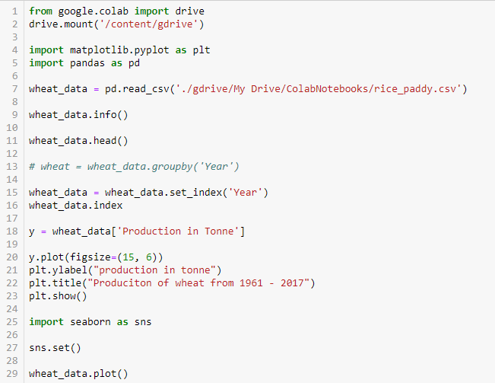

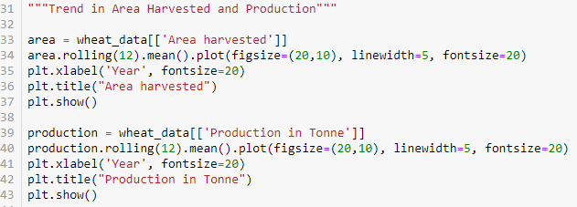

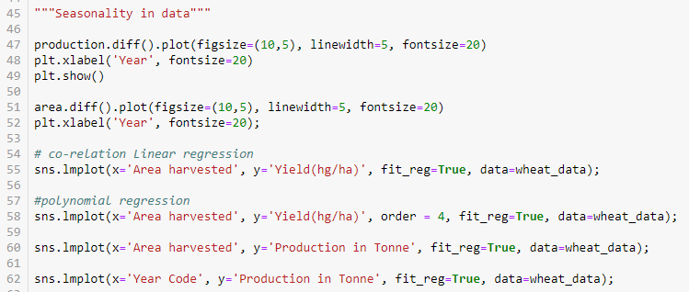

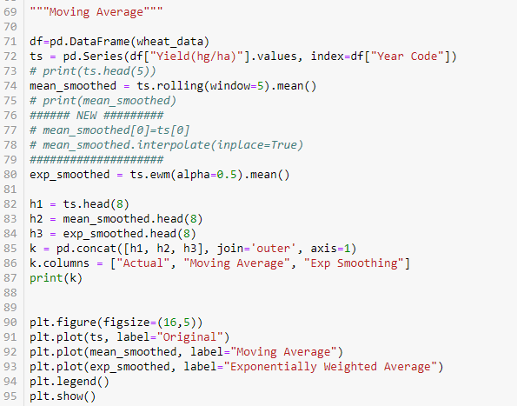

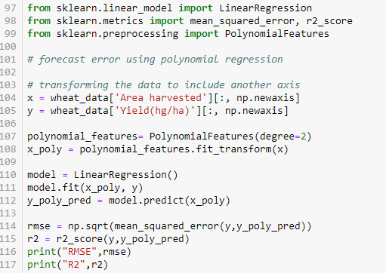

**Output:**

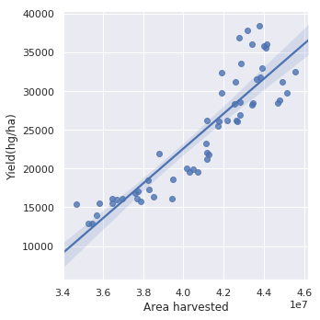

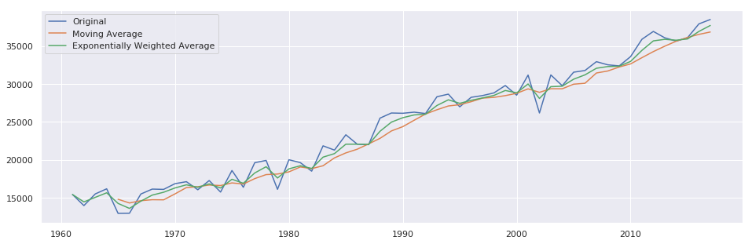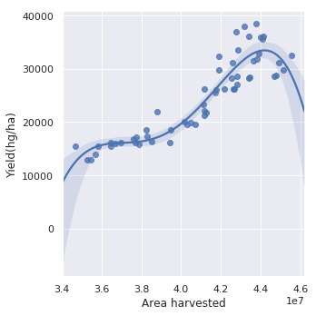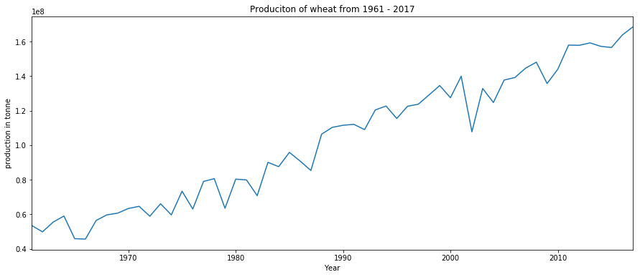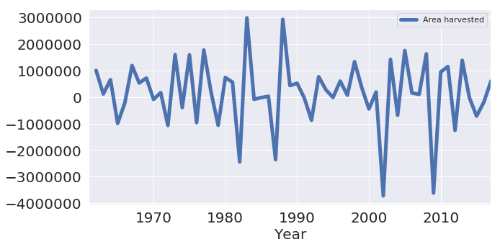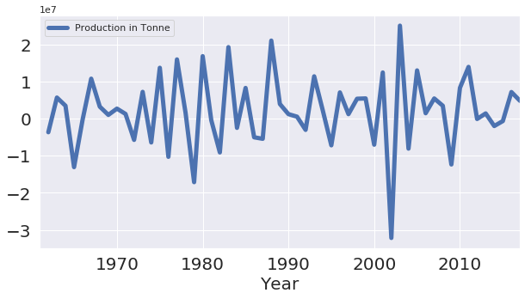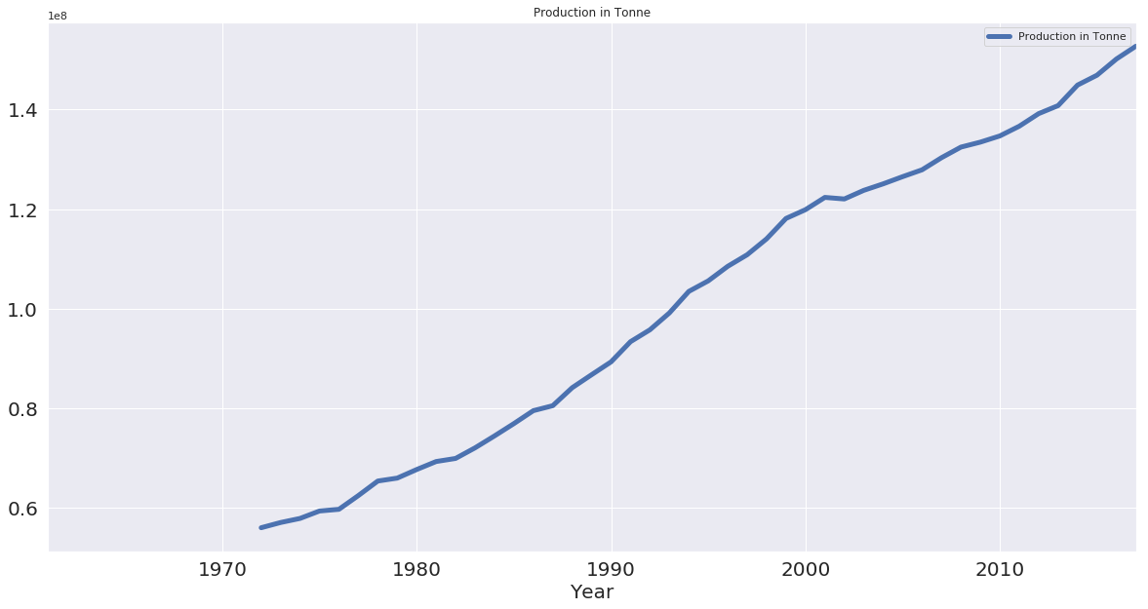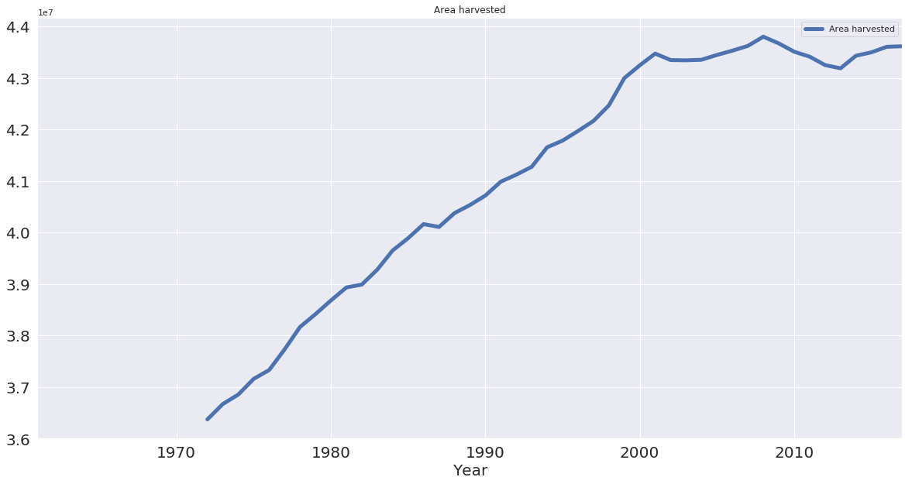

* **Objective**: Data Mining.
* **Programming Language**: Python 3 or above.
* **Time Required**: 3 Hours
* **Prerequisites and Programming skill:**

1. Python 3 or above should be installed on the computer.
2. Student must have basic understanding of clustering and classification.

**Data:** satellite data for a district, village level crop data.

* 5.1 Classify satellite data using k-means clustering algorithm and supervised MXL, and NN classifier and compare classification accuracy.

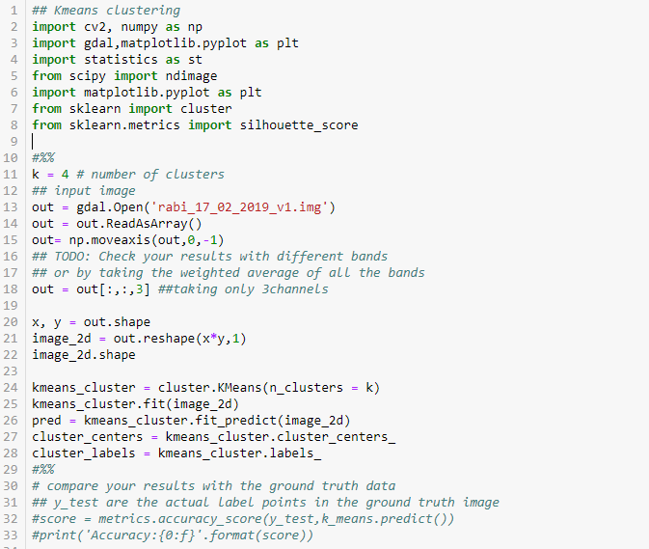

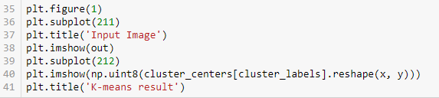

**Output:**

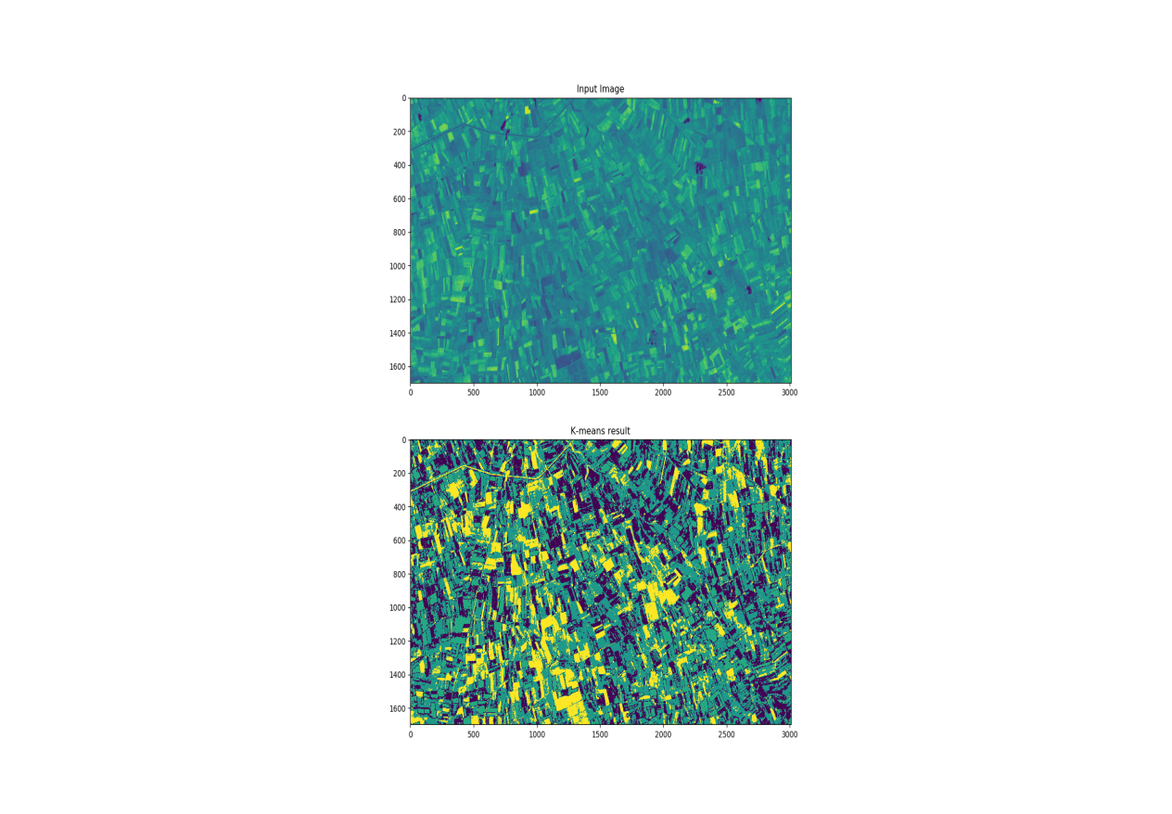

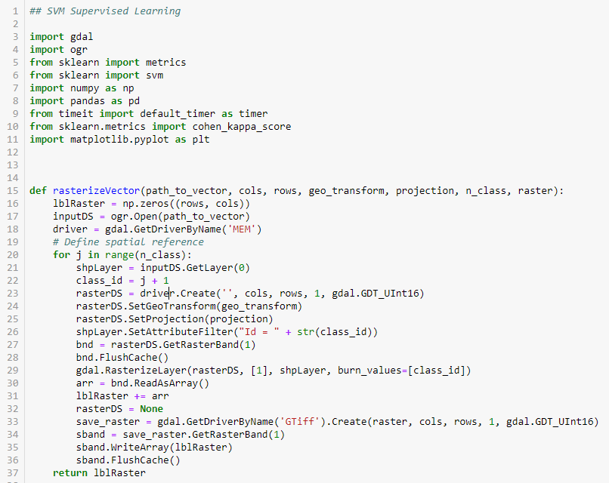

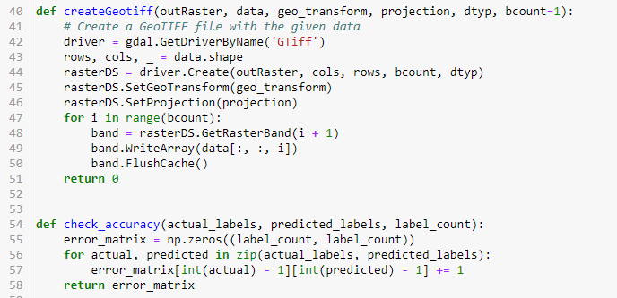

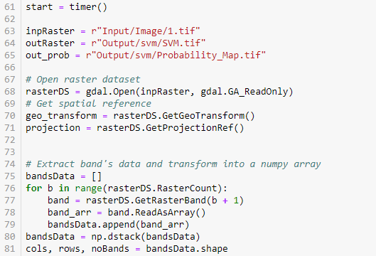

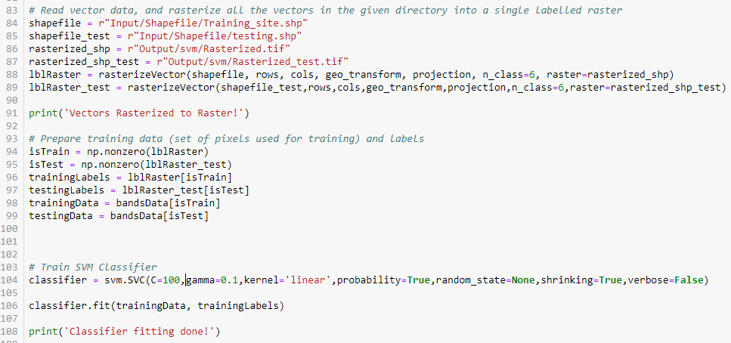

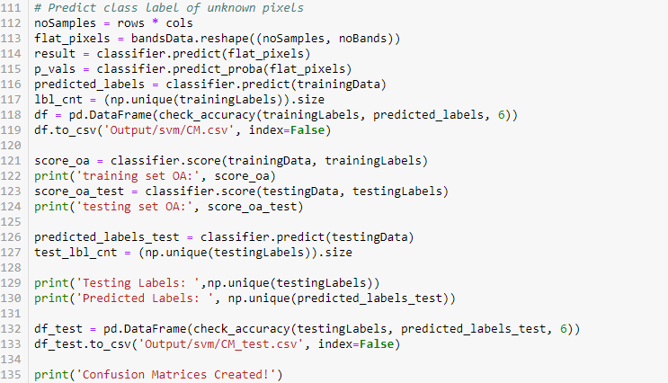

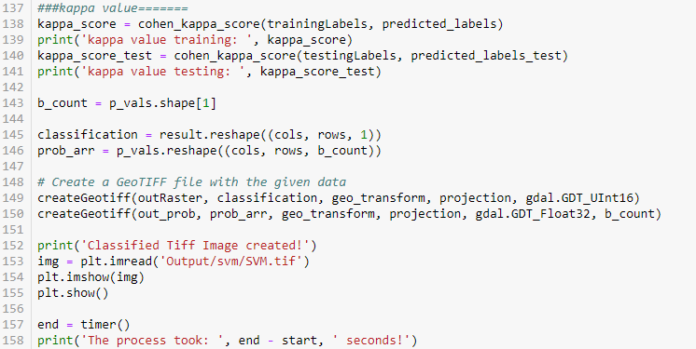

Output: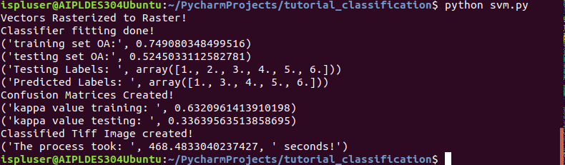

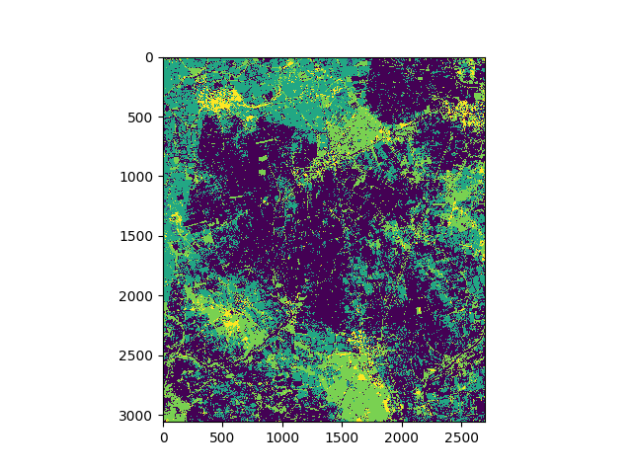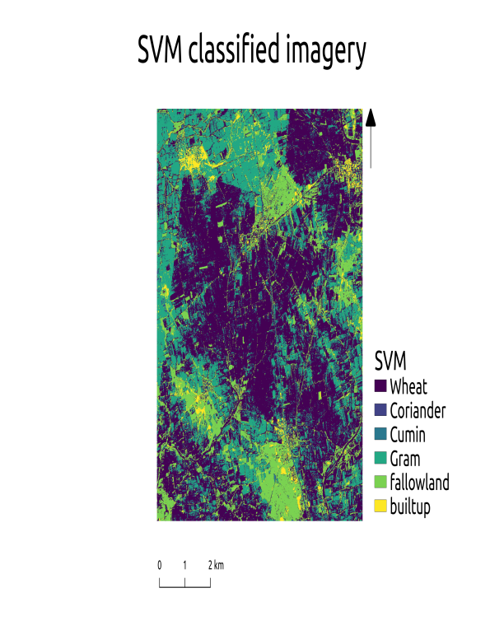

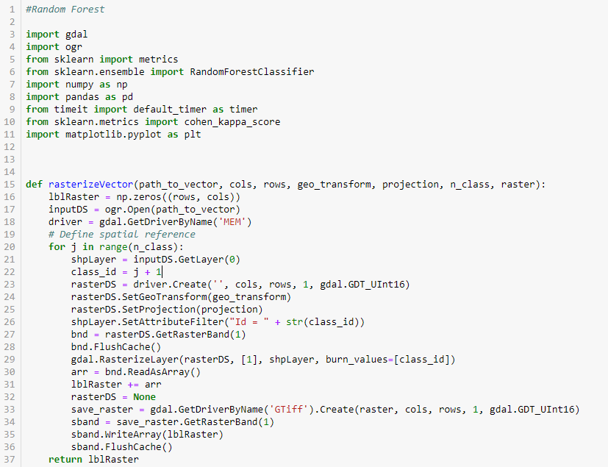

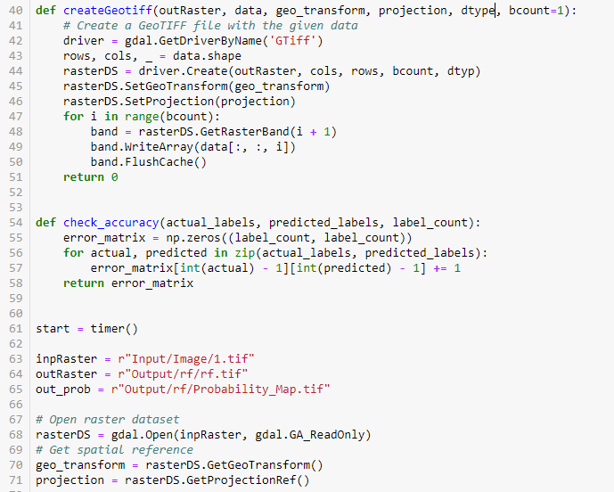

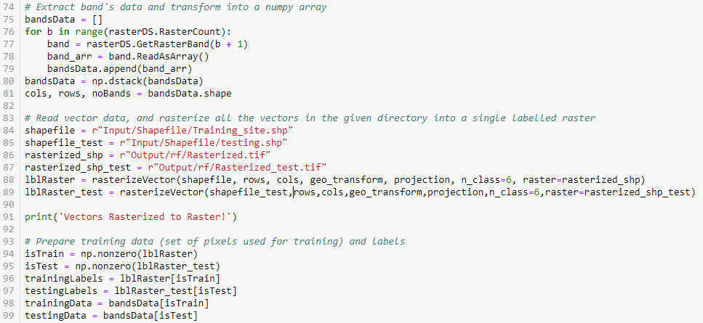

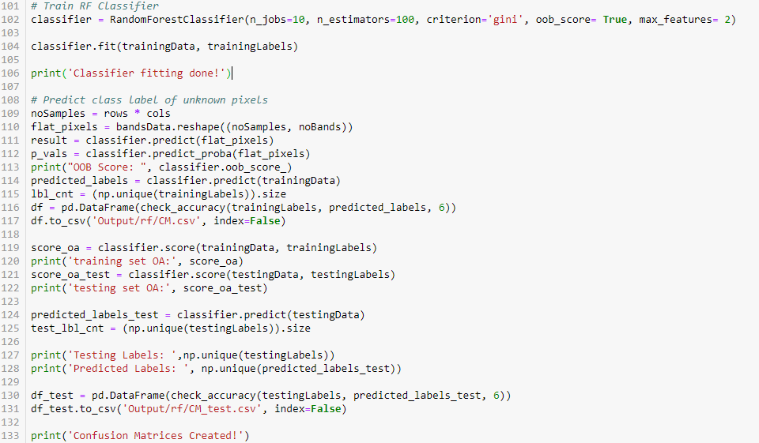

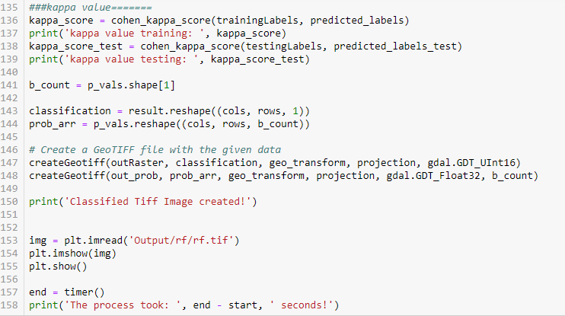

**Output:**

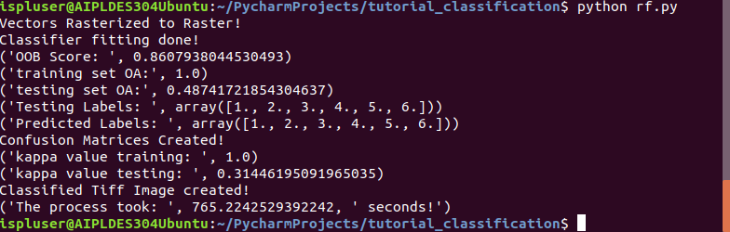

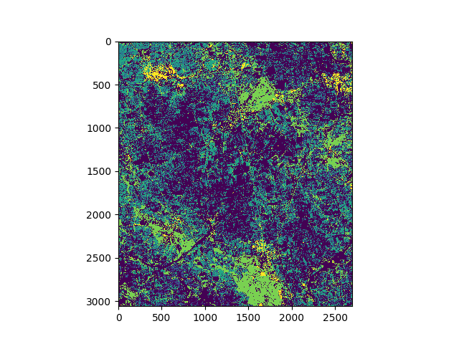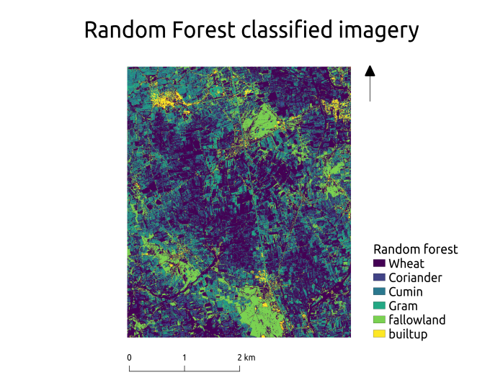

* **Objective**: Data Mining.
* 6.1 Simple Spreadsheet model of exponential light absorption vs LAI.
* 6.2 Light absorption (R)=R0exp(-kLAI).
* 6.3 Given values of R0 and LAI, vary k (extinction coefficient) and study effect on transmission rate.
* 6.4 Sample values of LAI from a normal distribution and repeat exercise.
* **Programming Language**: Python 3 or above.
* **Time Required**: 3 Hours
* **Prerequisites and Programming skill:**

1. Python 3 or above should be installed on the computer.
2. Student must have basic understanding of exponential.

**Data:** satellite data for a district, village level crop data.

* **Objective**: Data Mining.
* **Programming Language**: Python 3 or above.
* **Time Required**: 1 Hours
* **Prerequisites and Programming skill:**

1. Python 3 or above should be installed on the computer.
2. Student must have basic understanding of simplex method.

**Data:** P=207x + 200 y Subject to x>=o y>=0 x+y<=150 x<=60 30x+15y<=3000.

7.1 Since this is two variable problem, solve it graphically.

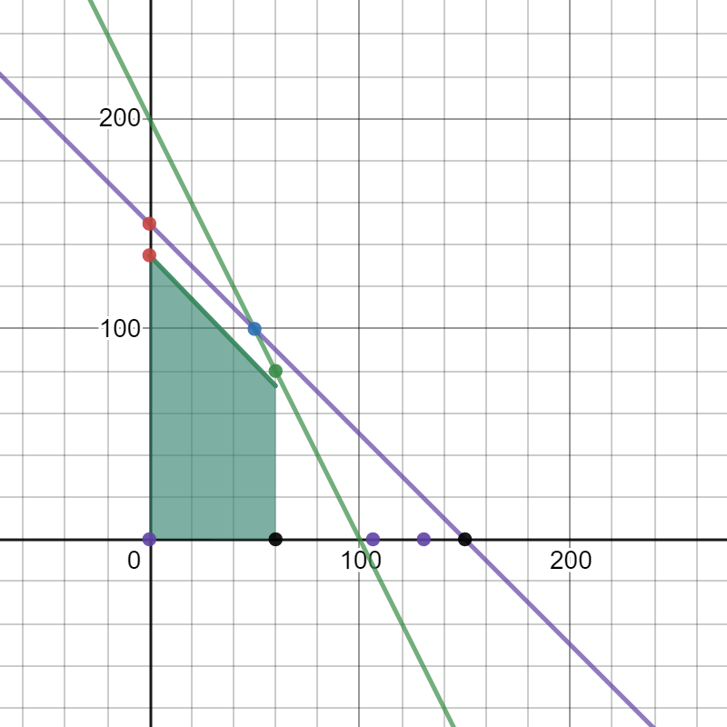

7.2 Use simplex method to solve the same.

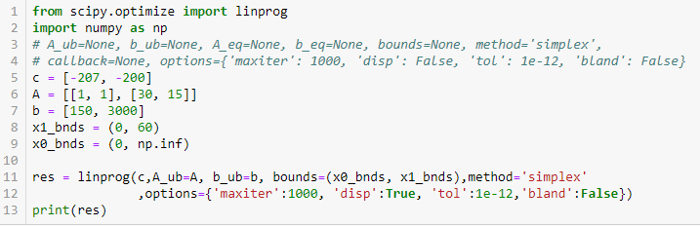

**Output:**

